Specifications:

Create LOGIN

Register

Shop

Database of users, Items

ERD Diagrams:

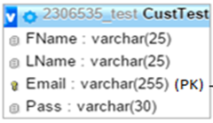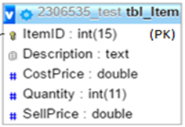

Feedback:

Comments - increased amount of comments

Table of items - on click